**Course Specialist Test 3 Year 12**

Student name: ________________ Teacher name: ________________

**Task type: Response**

**Reading time for this test : 5 mins**

**Working time allowed for this task: 40 mins**

**Number of questions: _____6______**

**Materials required:** Calculator with CAS capability (to be provided by the student)

Standard items: Pens (blue/black preferred), pencils (including coloured), sharpener, correction fluid/tape, eraser, ruler, highlighters

Special items: Drawing instruments, templates, notes on one unfolded sheet of   
A4 paper, and up to three calculators approved for use in the WACE examinations

**Marks available: ___39___ marks**

**Task weighting: _14___%**

**Formula sheet provided: no but formulae given on page 2**

**Note: All part questions worth more than 2 marks require working to obtain full marks.**

Useful formulae

Q1 (2, 3 & 3 = 8 marks)

An object starts from rest at the origin and moves with a velocity  m/s at time  seconds.

Determine the following.

1. Acceleration at time .

|  |
| --- |
| **c** |
|  |
| **Specific behaviours** |
| 🗸 diffs velocity  🗸 obtains acceleration function |

1. The cartesian equation of the path of the object.

|  |
| --- |
| **c** |
|  |
| **Specific behaviours** |
| 🗸 integrates and solves for constant  🗸 uses double angle formula for cosine  🗸 obtains expression in cartesian form (unsimplfied) |

1. Determine to the nearest second the first time for  that the acceleration and velocity are perpendicular.

|  |
| --- |
| **c** |
| Time = 1 second. |
| **Specific behaviours** |
| 🗸 sets up dot equation with v and a  🗸 equates to zero and solves for time  🗸 selects first time greater than zero and rounds to nearest second with units |

Q2 (5 marks)

If   find an expression for  in terms of .

|  |
| --- |
| **c** |
|  |
| **Specific behaviours** |
| 🗸 implicit diff used  🗸 product rule used correctly  🗸 chain rule used correctly  🗸 subs derivative  🗸 express second derivative in terms of x and y only |

Q3 (6 marks)

Sand is poured into a gigantic metal cone of height 15 m and a radius of 4 m at a rate of 120 cubic metres per minute, as shown below.

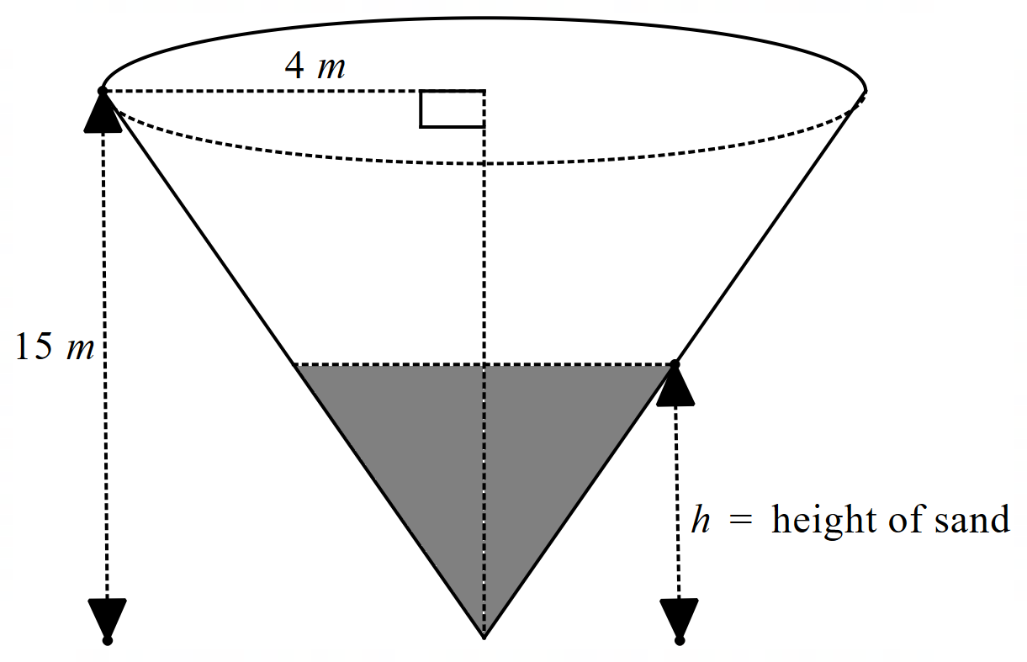

Determine the time rate of change of the height, metres, of the sand when the height is 5 m.

|  |
| --- |
| **c** |
|  |
| **Specific behaviours** |
| 🗸 uses volume of cone formula  🗸 determines ratio of radius to height  🗸 obtains expression for volume in terms of one variable  🗸 uses given rate of volume  🗸 obtains equation for height rate  🗸gives approx. or exact height rate with units |

Q4 (6 marks)

A water pipe of length 10 metres can be modelled by a cross-section 

where ,  and this curve is revolved about the x axis.

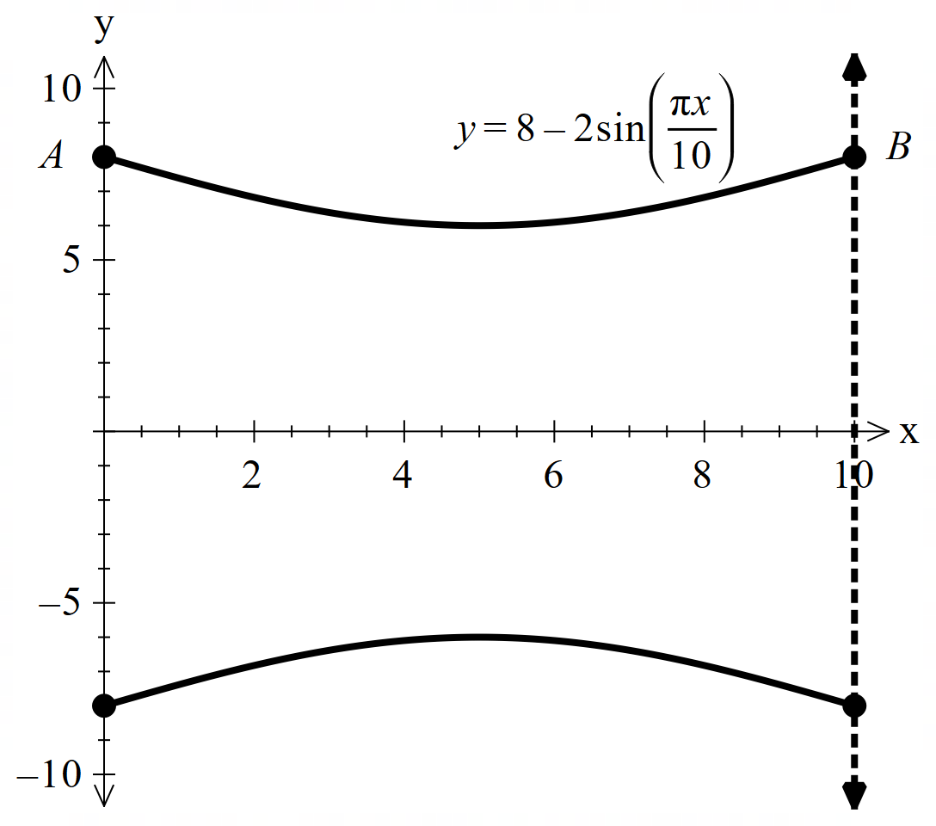

Determine the volume of water that this length of pipe will hold. Show all working **without** the use of a classpad.

|  |
| --- |
| **c** |
|  |
| **Specific behaviours** |
| 🗸 uses correct integral  🗸 expands the squared brackets  🗸 uses double angle formula  🗸 integrates correctly  🗸 subs both limits  🗸simplifies |

Q5 (5, 2 & 2 = 9 marks)

At time  years, 26 kangaroos are placed in an isolated habitat such that the number of kangaroos,  can be modelled by the differential equation .

1. Using separation of variables and partial fractions determine  **without** the use of a classpad.

|  |
| --- |
| **c** |
|  |
| **Specific behaviours** |
| 🗸 separates variables  🗸 uses partial fractions with correct coefficients  🗸 integrates correctly AND shows that absolute value not needed  🗸 rearranges for N(t)  🗸solves for constant exactly |

1. Determine the limiting value of the population of kangaroos.

|  |
| --- |
| **c** |
| Limiting value =100 kangaroos |
| **Specific behaviours** |
| 🗸 uses time approaches infinity  🗸 states limit (no need for units) |

Q5 cont-

1. Determine the time taken for the maximum growth rate.

|  |
| --- |
| **c** |
|  |
| **Specific behaviours** |
| 🗸 subs N= half of limiting value  🗸 approx. value of time, no need for units (accept exact) |

Q6 (5 marks)

Consider a woman of height 1.75 m, travelling at 2 m/s along the edge of a road of width 10 m. A lamp of height 6 m on the other side of the road, casts a shadow of the woman as shown below. Determine the time rate of change of the length of the shadow when m.

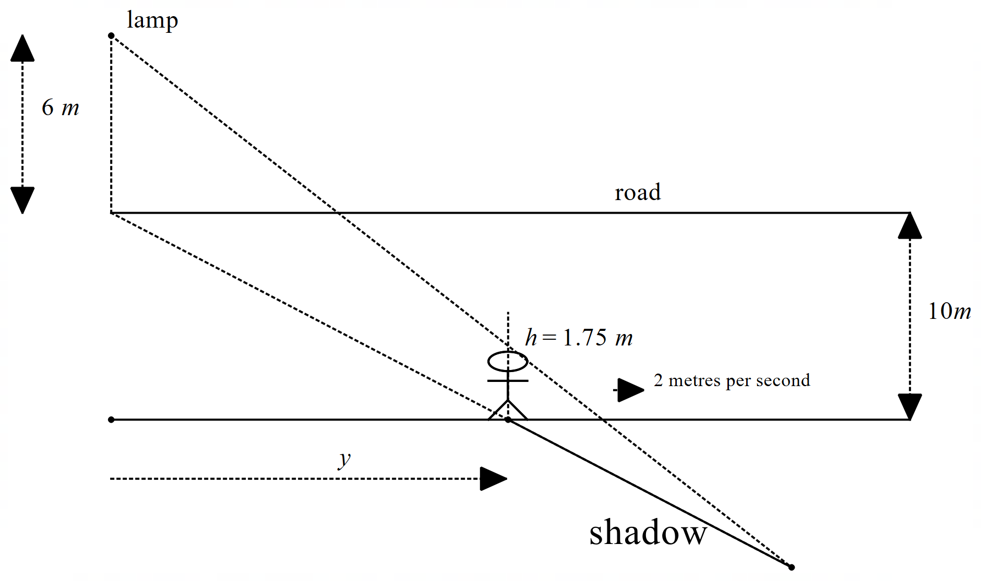

|  |
| --- |
| **c** |
|  |
| **Specific behaviours** |
| 🗸 uses similar triangles  🗸 obtains expression between y and length of shadow  🗸 uses implicit diff  🗸 obtains expression for time rate of length of shadow  🗸expresses exact simplified rate, no need for units |



**Working out space**